Day 49 – DEMUX Using 1:2 and 1:4 DEMUX

Introduction:Implemented DEMUX using 1:2 and 1:4 DEMUX using Verilog HDL.
A Demultiplexer (DEMUX) takes one input and sends it to one of the multiple outputs based on the select lines.
- 1:2 DEMUX
- 1:4 DEMUX

1. 1:2 DEMUX

Design: A 1:2 DEMUX has:
- 1 input → I
- 1 select line → S
- 2 outputs → Y0, Y1
Operation:
- S = 0 → Input goes to Y0
- S = 1 → Input goes to Y1

Design Code:

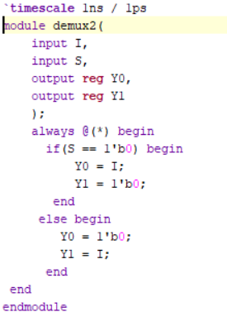

Testbench:

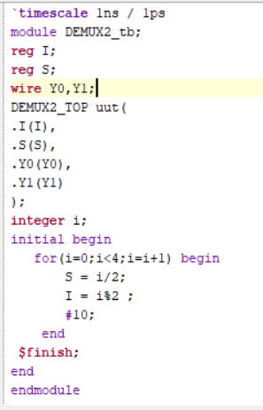

Waveform:

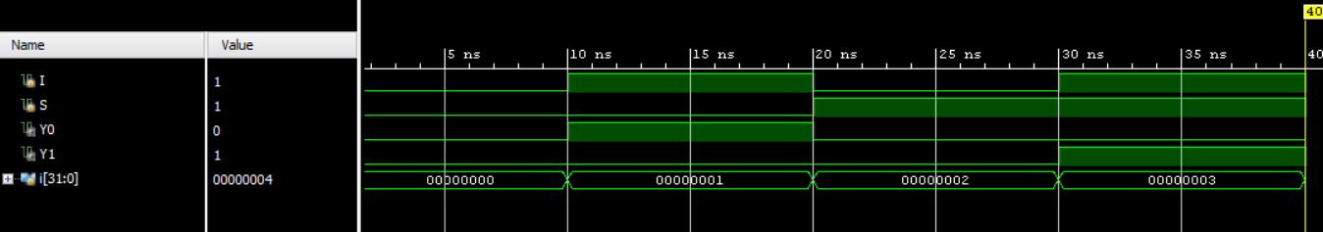

Schematic:

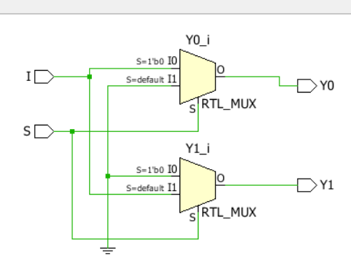

2. 1:4 DEMUX
A 1:4 DEMUX has:
- 1 input → I
- 2 select lines → S1, S0
- 4 outputs → Y0, Y1, Y2, Y3

Design
The select lines determine which output receives the input.
S1 S0

00 → Y0 = I
01 → Y1 = I
10 → Y2 = I
11 → Y3 = I
All other outputs remain 0.

Design Code:

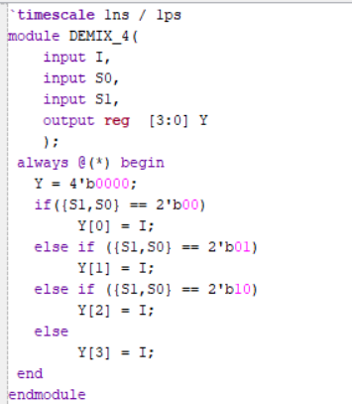

Testbench:

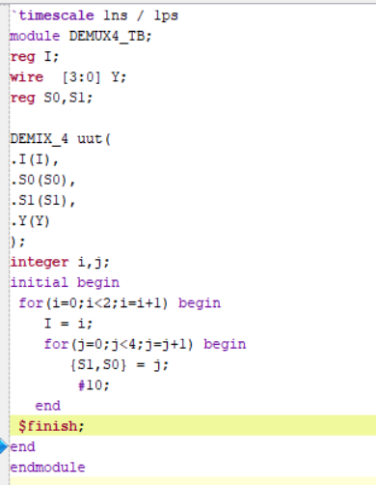

Waveform:

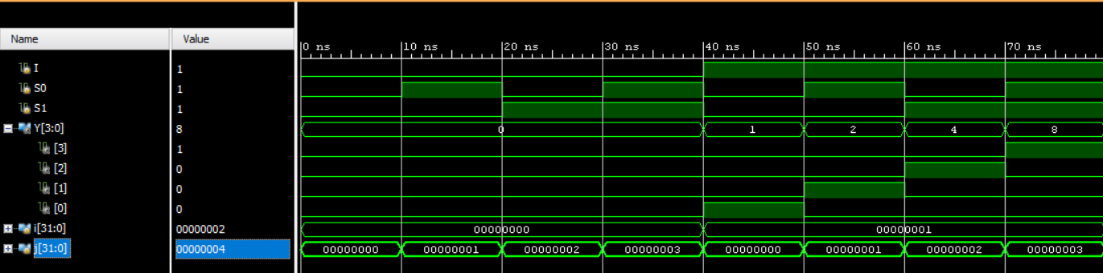

Schematic:

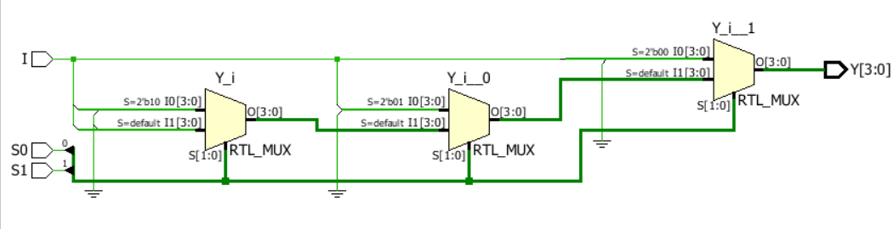

Observation:
- 1:2 and 1:4 DEMUXes were successfully implemented using Verilog HDL.
- The input was routed to the selected output correctly.
- The designs were verified using Testbench and Simulation.
- Waveforms and RTL schematics were analyzed using Xilinx Vivado.
- This implementation helped me understand how DEMUXes route a single input to multiple outputs.

#PHANEEENDRA.SINGUDASU

